PROJECT TEMPLATE

Proposals will be submitted in English. Each proposal must comprise two parts: Part 1 (containing administrative information) and Part 2 (containing the description of the proposal):
- Part 1 contains a cover page and a set of tables to provide administrative data
- Part 2, the main section of the proposal must not exceed 20 pages in length. The descriptive text should be no smaller than 12-point Calibri (Corp) font.
- The connection methods description and non-applicable section should be deleted before submission.

Part 1 – Administrative information
Name of organisation (in full)
The legal form of organisation (e.g. SA)
Date and country of registration
Registration number
VAT number
Registered office address
Administrative address
(if different from above)
Total number of employees
Name of the legal representative
Position (e.g. Manager)
Telephone number
E-mail address
Name of the contact person
Position (e.g. Manager)
Telephone number
E-mail address
Website of organisation

Part 2 – Description of the proposal
This section is applicable to Cyber Range Providers.
- Cyber Range Name
- Cyber Range Website URL (if applicable)
- Description of Cyber Range Purpose and Target Audience (Max. 300 words)
- Key Features and Functionalities of the Cyber Range (Bullet Point List)
- Number of Active Users (Approximate)
- Number of Scenarios Currently Available (Approximate)
- Types of Exercises Supported (e.g., Attack/Defense, Red/Blue Team, Forensics, Incident Response)
- Attach: Cyber Range Brochure or Overview Document (Optional)
Applicant Maturity Level:
- Infrastructure Provider (have resources but lack orchestration capabilities)
- Cyber Range Provider (operate an existing functional cyber range)
Current Production Status:
- Operational (already running exercises)
- In Development
- Planning Phase
Section 3: Available Infrastructure Resources
This section is applicable to Infrastructure Providers.
- Core Infrastructure:
  - Minimum 32 vCPU [M]
  - Minimum 64 GB RAM [M]
  - Minimum 0.5TB SSD Storage [M]
  - Recommend 1 GBit Network Connection [M]
- Network Infrastructure:
  - Dedicated Internet Connection [M]
  - BGP Support [O]
  - Support for VXLAN/NVGRE [O]
  - Hardware Firewall [M]
  - Load Balancer [O]
  - VPN Concentrator [M]
- Virtualization Infrastructure:
  - Dedicated Hypervisor Cluster [M]
  - High Availability Configuration [O]
  - Backup Infrastructure [O]
  - Disaster Recovery Site [O]
- Physical Infrastructure:
  - Dedicated Data Center Space [O]
  - Redundant Power Supply [O]
  - Environmental Controls [O]
  - Physical Security Controls [M]
- Monitoring Infrastructure:
  - Network Monitoring Tools [O]
  - Performance Monitoring [O]
  - Security Monitoring [O]
  - Log Management System [O]
Section 4: Technical Capabilities and Integration Readiness
This section is applicable to Infrastructure Providers & Cyber Range Providers.
- Detailed Description of Cyber Range Functionalities (Scenario Creation, Virtual Environment Management, Exercise Control, Logging, Reporting, User Management - Max. 500 words)
- Primary Integration Method (select at least one):
  - API Connection (VSphere/Proxmox) [O]
  - Hybrid Connection (WireGuard/OpenVPN) [O]
  - API Connection (Kubernetes) [O]
  - Non-standard Integration with CyberEDU Infragator [O]
  - Cross-range using IPSEC/VPN tunnels [O]
- Technical Specifications and API Documentation Availability (Yes/No - If Yes, Please Attach)
- Description of Security Protocols and Standards Implemented in the Cyber Range (Max. 300 words)
- Resource Specifications (Compute, Storage, Network) Available for Integration (Provide details and approximate capacity)
Section 5: Operational and Security Information
This section is applicable to Infrastructure Providers & Cyber Range Providers.
- Description of the Team Responsible for Cyber Range Operation and Support (Team Size, Key Roles, Expertise - Max. 300 words)
- Summary of Security Policies and Procedures in Place (Max. 300 words)
- Cyber Range Uptime and Availability Records (Provide approximate uptime percentage or relevant metrics)
- Description of Disaster Recovery and Business Continuity Plans (Max. 200 words)
Section 6: Motivation and Alignment
This section is applicable to Infrastructure Providers & Cyber Range Providers.
- Reasons for Applying to Join CYRESRANGE (Max. 300 words)
- Expected Benefits from Onboarding to CYRESRANGE (Max. 300 words)
- How Your Cyber Range Aligns with the Vision and Goals of CYRESRANGE (Max. 300 words)
- Commitment to Collaboration and Knowledge Sharing within the CYRESRANGE Community (Describe your organization's approach - Max. 200 words)

Section 7: Work Plan and Deliverables (Mandatory Structure)
This section is applicable to Infrastructure Providers & Cyber Range Providers.
Applicants must structure their implementation plan according to the following mandatory Work Packages:
WPs | Activities | Deliverable
WP1 – Project Management | Activities shall include:  - Project coordination  - Technical coordination meetings  - Risk monitoring  - Communication with CYRESRANGE technical team | Deliverable shall include:  - Summary of activities performed  - Issues encountered and mitigation actions  - Confirmation of completion of planned activities
WP2 – Onboarding & Technical Integration | Activities shall include:  - Infrastructure preparation  - Configuration of selected integration method  - API/VPN/IPSEC implementation  - Network configuration and routing  - Access provisioning to CYRESRANGE  - Technical validation of connectivity | Deliverable shall include:  - Architecture description  - Integration method implemented  - Technical configuration details  - Evidence of API/VPN connectivity  - Resource allocation details  - Screenshots/logs as proof of integration
WP3 – Testing & Validation | Activities shall include:  - Cross-range validation (where applicable)  - Performance and interoperability testing  - Identification of technical improvements | Deliverable shall include:  - Test results  - Identified issues and resolution  - Feedback on onboarding process  - Integration challenges  - Recommendations for improvement

Section 8: Requested Budget
Task | A. Personnel |  | C.1 Travel and subsistence | C.3 Other goods, works and services | E. Indirect costs | Total costs | In Kind Contribution
 | Person Months | Total Euro
WP1 - Project Management
T1.1
T1.2
T1.3
WP2 - Onboarding & Technical Integration
T2.1
T2.2
...............
WP3 - Testing & Validation
........
Total | 0 | 0 | 0 | 0 | 0 | 0 | 0

Section 9: Declaration and Signature
This section is applicable to Infrastructure Providers & Cyber Range Providers.
- Declaration: "I hereby declare that the information provided in this application is true and accurate to the best of my knowledge. I understand and agree to the terms and conditions of the Call for Onboarding Independent Cyber Ranges to CYRESRANGE."
- Name of Authorized Representative
- Title of Authorized Representative
- Date
- Signature (or electronic equivalent) - A Qualified Electronic Signature (QES) is necessary

Please note that, in the proposal, you must select one of the five methods of connection between cyber ranges as described below.

Methods of connection between cyber ranges
The methods of connecting cyber ranges can be broadly classified into five categories:
- API connection for Vsphere/Proxmox: This method utilizes API calls to manage and control virtual machines and network resources within the cyber range environment.
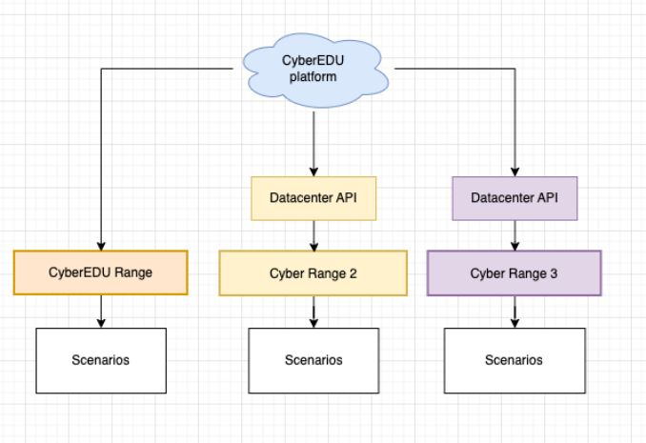
Figure 1 – API connection for Vsphere/Proxmox diagram
- Hybrid connection: This involves establishing a secure connection between a virtual machine within the cyber range and a remote facility, often using technologies like WireGuard or OpenVPN.
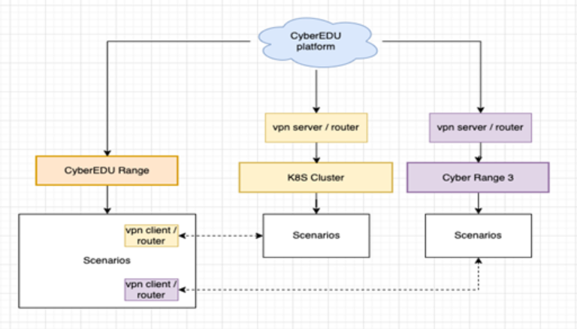
Figure 2 – Hybrid connection diagram
- API connection for Kubernetes: Similar to the Vsphere/Proxmox connection, this method uses API calls to manage containerized environments and resources within the cyber range.
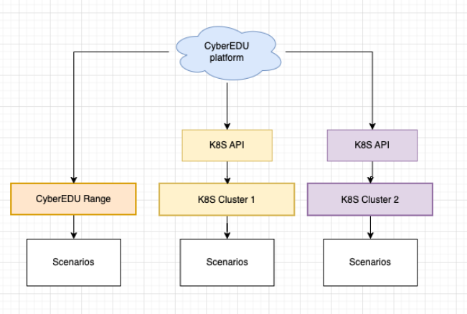
Figure 3 – API connection for Kubernetes diagram
- Non-standard integration with CyberEDU Infragator: This involves utilizing the CyberEDU Infragator tool for specialized integration and control of specific cyber range components.
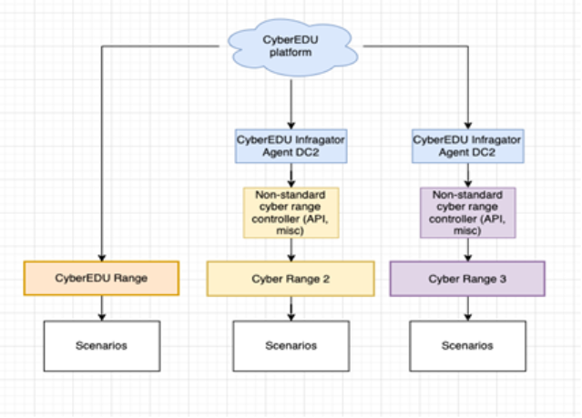
Figure 4 – Non-standard integration with CyberEDU Infragator diagram
- Cross-range using IPSEC/VPN tunnels: This method establishes secure tunnels between different cyber ranges to facilitate communication and resource sharing.
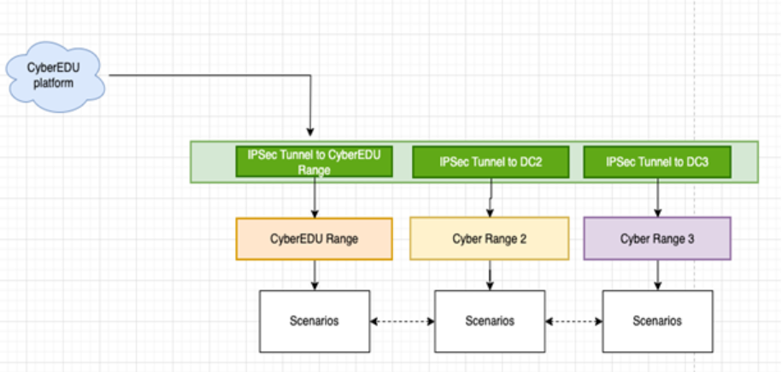
Figure 5 – Cross-range connection using IPSEC/VPN tunnels diagram

Sometimes we might combine an API-type of integration with some routing capabilities in order to link resources and make them accessible for each Datacenter for best experience. In order to have a better understanding, we defined several metrics and factors to follow:
Table 1 – Considered matrics and factors in terms of connection/integration of cyber ranges
Benefit | API connection for Vsphere/Proxmox | Hybrid Connection (Wireguard) | API connection for Kubernetes | CyberEDU Infragator | Cross-range using IPSEC/VPN tunnels
Complexity for the Cyber Range / Infrastructure Provider | Medium | Hard | Medium | Easiest | Hard
Expertise Requirements for the Cyber Range | datacenter management | no special requirements | Kubernetes management | no special requirements | networking, firewall policies, vpn configuration
Type of integration | At the level of the platform | At the level of the scenario (within a datacenter) | At the level of the platform | At the level of the platform | At the level of the infrastructure (datacenter)
Resource Access | VMs or Containers | VMs, Containers, Physical Appliances | Containers | Custom integration | VMs, Containers, Physical Appliances
Management of Labs | CyberEDU platform | Cyber Range | CyberEDU platform | CyberEDU platform | Cyber Range
Minimum necessary resources | Vsphere / Proxmox Datacenter  VM with a special VPN server provided by CYRESRANGE  Minimum: 2 TB, 128 GB RAM, 64 VCPUs for scenarios | Wireguard / openvpn server  Firewall and routing policies to allow CYRESRANGE access local network  Minimum: 2 TB, 128 GB RAM, 64 vCPUs for scenarios and/or specific appliance | Kubernetes Cluster with API credentials  External/VPN access to the K8S cluster services.  Minimum: 500GB, 16 GB RAM, and 16 vCPU for scenarios | Virtual Machine with CyberEDU Infragator installed  API integration developed to support the existing service (eg. not supported VMs orchestrator etc)  Minimum: 500 GB, 16 GB RAM, 16vCPUs for scenarios and/or specific appliance | IPSec tunnel configuration  Firewall and routing policies to allow CYRESRANGE access local network  Minimum: 2 TB, 128 GB RAM, 64 vCPUs for scenarios and/or specific appliance
Validation method | API connectivity  Access to upload and manage images, vms, virtual networks, storage  Access to the infrastructure via VPN | VPN Client connectivity to remote site and virtual/physical appliances accessible as a client, including routing traffic | API connectivity  Access to deploy pods, services, check nodes status etc. | Connectivity to Cyberedu platform from CyberEDU Infragator Agent.  Access to services deployed by the Cyber Range | IPsec tunnel established. Proper traffic routing to the virtual/physical appliances.

